Introduction

The rapid adoption of machine learning in financial fraud detection has produced highly accurate models at the cost of interpretability. Ensemble methods and deep neural networks routinely achieve strong detection performance on large, imbalanced transaction datasets, yet their decision logic remains unclear to the human investigators who act on their outputs (Almalki & Masud, 2025). This vagueness creates two concrete problems. First, investigators cannot distinguish a model’s genuine pattern recognition from false correlations, which increases the risk of acting on unreliable alerts. Second, regulations such as the GDPR’s Article 22 impose a legal obligation to provide meaningful explanations for automated decisions that carry significant consequences for individuals, including the flagging of a financial transaction as fraudulent. These pressures have motivated a growing body of work on applying XAI methods to fraud detection systems.

The dominant approach in this space has been feature attribution. Lundberg and Lee (2017) introduced SHAP, which uses Shapley values from cooperative game theory to assign each feature a contribution score for a given prediction. Applied to fraud detection, SHAP produces a ranked list of features that pushed a transaction towards or away from the fraud class, offering investigators a transparent audit trail. However, attribution methods carry a fundamental limitation in this context: they answer which features mattered, but not what specifically distinguishes a fraudulent transaction from a legitimate one. A high attribution score on a particular feature tells an investigator that the feature was important, but not whether its presence, absence, or specific value is the defining characteristics of the anomaly. This limits the operational usefulness of the explanation for investigators who need to act quickly on individual alerts.

Contrastive explanation methods address this gap directly. Dhurandhar et al. (2018) introduced CEM, which identifies a minimal set of features that must be present to sustain a fraud prediction and the minimal set that must be absent. This contrastive framing maps more naturally to investigator reasoning, yet CEM has seen limited evaluation in highly imbalanced, tabular financial datasets where the class boundary is particularly irregular. This study therefore asks: to what extent does CEM provide more actionable insights for fraud investigators compared to SHAP in highly imbalanced financial data sets?

Methods
SHAP – Shapley Additive Explanations
SHAP is a post-hoc explanation method grounded in cooperative game theory (Lundberg & Lee, 2017). It assigns each feature a contribution score by computing its average marginal contribution across all possible feature subsets. For tree-based models, SHAP’s TreeExplainer computes these values exactly by traversing the decision paths of all trees, with no sampling approximation needed. In the fraud detection context, this produces a local explanation per transaction: a signed vector where positive values push toward fraud and negative values push away, giving investigators a transparent audit trail per alert.

CEM – Contrastive Explanation Method

CEM, introduced by Dhurandhar et al. (2018), produces explanations by finding two complementary feature sets. Pertinent Positives (PPs) are the minimal subset of features sufficient to maintain the fraud prediction. Pertinent Negatives (PNs) are features whose absence is critical, including them would make the prediction legitimate. Both solutions are achieved through constrained optimisation with an L1 penalty, which encourages the solution to utilise the fewest features possible. Unlike SHAP, CEM does not rank all features but instead identifies the smallest contrastive evidence, mapping directly onto how investigators reason: “what made this transaction suspicious, and what would have made it look normal?”
Evaluation

This study defines actionable insight using two metrics. First, sparsity: fewer highlighted features means a more actionable explanation, as investigators have limited time per alert. Second, sufficiency: for SHAP, the minimum number of top-k features that reproduce at least 90% of the original fraud score; for CEM, the number of features in the PP. Both methods are applied to a Random Forest classifier trained on the ULB credit card fraud dataset, wit SMOTE applied only to the training set to handle class imbalance without data leakage.

Results
The Random Forest Classifier achieved a ROC-AUC of 0.9775 on the original test set, with a recall of 0.86 for the fraud class. This means that 86% of the actual fraud cases were correctly marked. The fraud precision was 0.44, highlighting the inherent challenge of the severe class imbalance with a 0.17% fraud rate. Even a strong model produces some false positives. These results confirm the classifier’s reliability in evaluating explanation quality.
SHAP results
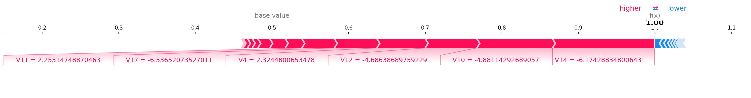
The summary plot (figure 1) shows that V14, V10, V4 and V12 consistently received the high mean absolute SHAP values across 50 fraud transactions, identifying these as the most globally influential features. The force plot for a single transaction (Figure 2) illustrates how individual features push the prediction toward fraud (red) or away from it (blue), with V11, V4 and V12 driving the prediction to a score of 1.00. the sparsity analysis (figure 3) shows that on average, SHAP required 7.3 features to reproduce 90% of the original fraud score, with most transactions failing between 7 and 8 features.
Figure 2: SHAP force plot for a single fraud transaction. Red arrows push toward fraud, blue arrows push away.

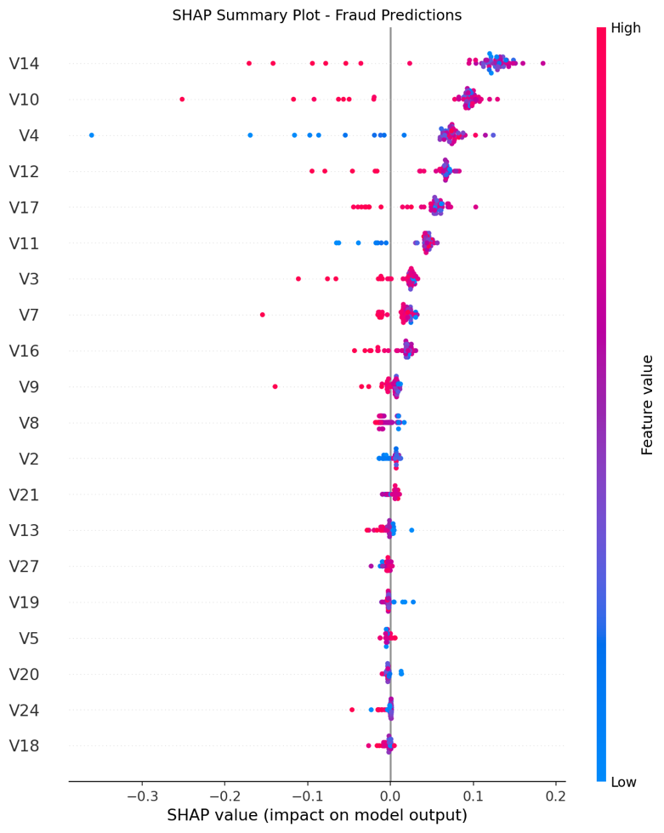

Figure 1: SHAP summary plot showing mean absolute feature contributions across 50 fraud transactions.
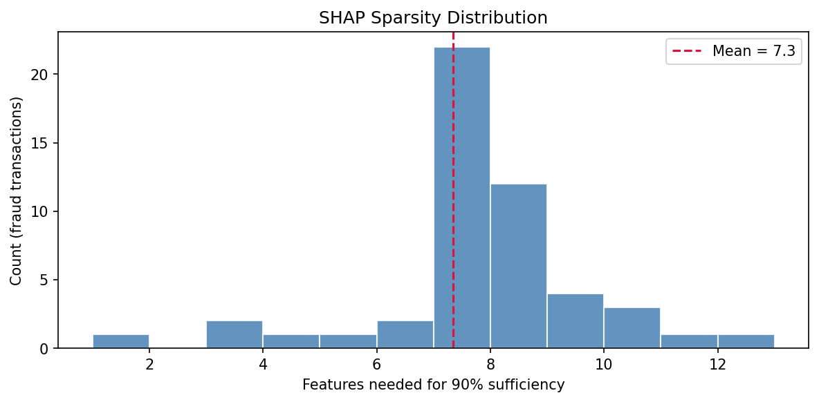

Figure 3: Distribution of features needed to reproduce 90% of the fraud score across 50 transactions (mean = 7.3).

CEM results
Across the three case study transactions, CEM identified Pertinent Positves of exactly 5 features each, yielding a mean sparsity of 5.0 features. The feature Amount appeared as a PP in all three transactions, while V14 ad V2 each appeared in two. The comparison plot (figure 4) shows limited overlap between SHAP’s globally important features and CEM’s PPs: SHAP highlights V14, V10, and V4 as the strongest global contributors. CEM consistently surfaces Amount, V14, and V2 as the minimal sufficient evidence per transaction. Remarkably, the PN sets were empty for all three transactions. This suggests the optimiser did not find a small enough change to flip the prediction. Therefore, these fraud cases were robustly classified.

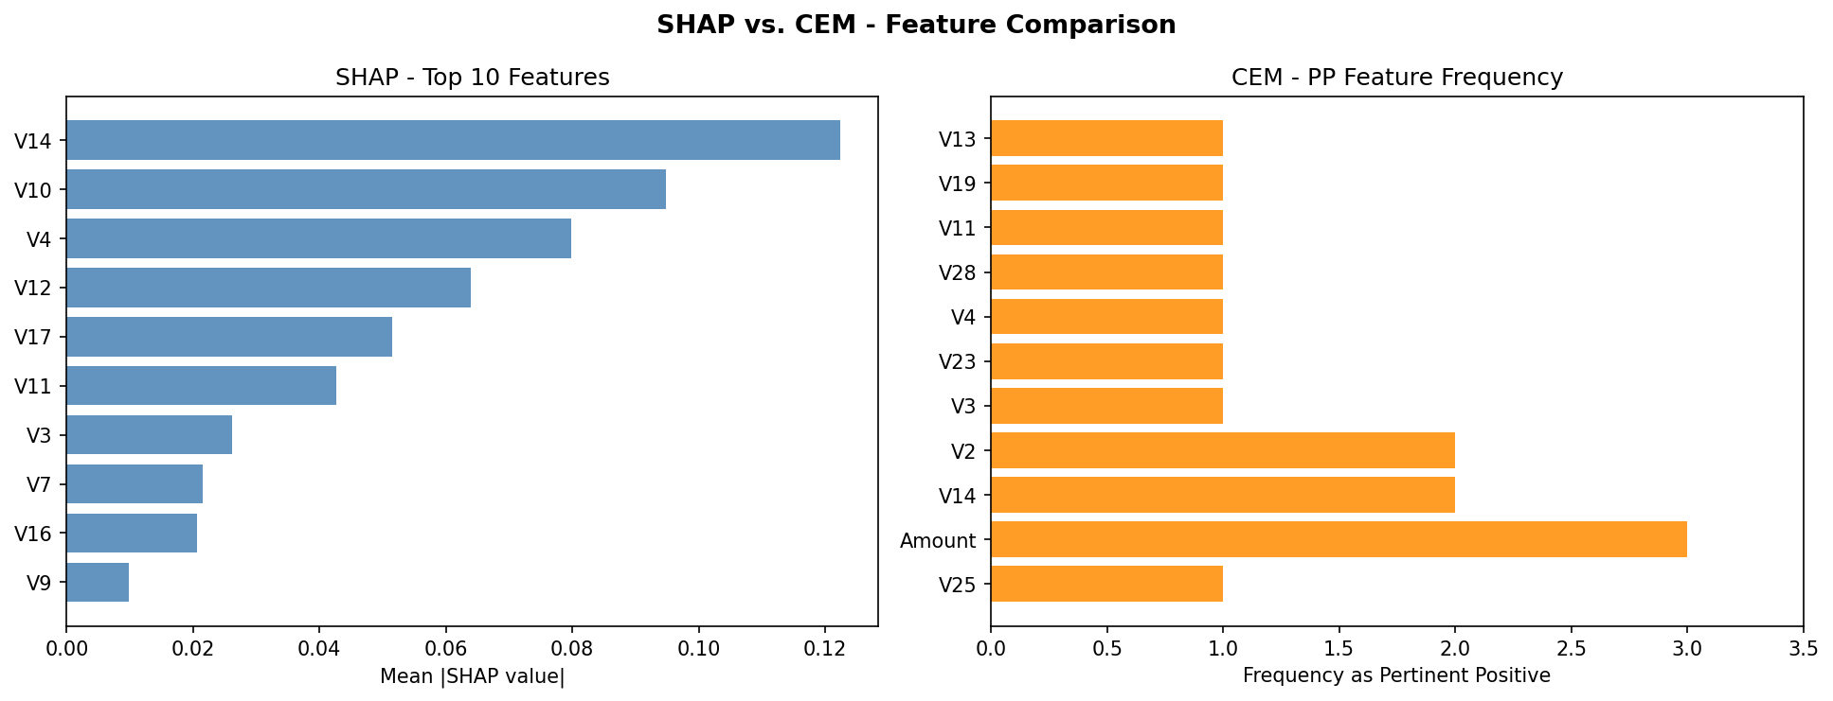
Figure 4: Comparison of top features identified by SHAP (left) and CEM Pertinent Positives (right) across case study transactions.
Actionability comparison
CEM produced sparser explanations (mean 5.0 features) than SHAP (mean 7.3 features), a difference of 2.3 features per transaction on average. This suggests that CEM provides more concise and therefore more actionable explanations for fraud investigators.
Method | Mean features for sufficiency | Metric
SHAP | 7.3 | Min top-k for 90% score
CEM (PP) | 5.0 | L1-regularised optimisation

Discussion
The results provide partial support for the hypothesis that CEM generates more actionable explanations than SHAP in this setting. CEM’s Pertinent Positives were consistently sparser, requiring on average2.3 fewer features to characterise a fraud prediction. For a bank investigator reviewing dozens of alerts per shift, this difference is practically meaningful: a five-feature explanation is cognitively easier to act on than a seven-feature one.
The consistent appearance of Amount in all three CEM PPs is an intere

Discussion

References:
Lundberg, S. M., & Lee, S.-I. (2017). A unified approach to interpreting model predictions. Advances in Neural Information Processing Systems, 30, 4765–4774. https://doi.org/10.48550/arXiv.1705.07874
Almalki, F., & Masud, M. (2025). Financial fraud detection using explainable AI and stacking ensemble methods. IEEE Access. Advance online publication.
https://doi.org/10.48550/arXiv.2505.10050
Dhurandhar, A., Chen, P.-Y., Luss, R., Tu, C.-C., Ting, P., Shanmugam, K., & Das, P. (2018). Explanations based on the missing: Towards contrastive explanations with pertinent negatives. Advances in Neural Information Processing Systems, 31, 592–603. https://doi.org/10.48550/arXiv.1802.07623
Machine Learning Group - ULB (2018). Credit Card Fraud Detection Dataset. Kaggle. https://www.kaggle.com/mlg-ulb/creditcardfraud

